A

Project Design Report on

"Energy Efficient IOT-Home Automation "

Submitted by

##### Mr. Nagane Abhijit Shantaram Mr. Mutkule Abhijeet Kashinath Mr. Kolhe Pranjal Milind

Mr. Pathak Vinayak Vijay

Under The Guidance of DR. V. A. Dhotre

For The Award of The Degree of Bachelor of Engineering



DEPARTMENT OF COMPUTER SCIENCE AND ENGINEERING

SKN SINHGAD COLLEGE OF ENGINEERING

(PUNYASHLOK AHILYADEVI HOLKAR, SOLAPUR UNIVERSITY)

2020-2021

DEPARTMENT OF COMPUTER SCIENCE AND ENGINEERING

SKN Sinhgad College of Engineering, Korti, Pandharpur.



CERTIFICATE__

This is to certify that, the project design report entitled

"Securing and Managing Patient Data of Rural Healthcare System Through Cloud Environment"

Submitted by

Mr. Abhijit S. Nagane

Mr. Abhijeet K. Mutkule

Mr. Pranjal M. Kolhe

Mr. Vinayak V. Pathak

In the partial full fllment for the award of the Degree of Bachelor of Engineering

This Project design work is a record of student's own work carried out by them under my supervision and guidance during the academic year

2020-2021

Prof. V. A. Dhotre

Project Guide

Prof. N. M. Sawant

Head of Department

## Abstract

This project revolves around creating a smart home system prototype with the main focus being the ability to lock/unlock a door through the internet. The system consists of a central device, a server and an Android application.

The central device is a microprocessor, in this case, a Raspberry Pi that connects to the Internet and receives an order to control a motor which in turn turns the lock with the help of gears. The ability to rotate the motor in both directions is achieved by the use of an H-bridge. The server manages users and devices, and handles the communication between the application and the central device. Users and devices are stored in a database on the server. The application is a frontend which presents the user with a list of devices to interact with.

The main prototype where the Raspberry Pi acted as a central device was abandoned due to time and resource constraints. It was instead used to control the motor directly. This brought up some problems concerning powering the device using batteries. The software of the prototype is mostly working but due to the same time limitations not all planned features could be implemented.

# CONTENTS

#### Introduction 6

#### Literature review 8

#### Problem Statement And Objectives 10

#### Methodology 11

#### UML Diagrams 12

Use case diagram Data Flow Diagram Activity Diagram Sequence Diagram

#### System Requirements 18

Hardware Requirement Software Requirement

#### Conclusion 19

#### References 21

List of Figures

##### 1.1Smart home system architecture

2.1 Basic block diagram of smart home system

* 1. Proposed System
  2. Connections
  3. System use case diagram
  4. Data flow diagram (level 0)
  5. Data flow diagram (level 1)
  6. Activity Diagram
  7. Sequence diagram

Chapter 1 Introduction

Today, technology has become an integrated part of people's lives. It has, and continues to influence many aspects of daily life and has allowed better social interaction, ease of transportation, the ability to indulge in entertainment and media and has helped in the development in medicine. The creation of many devices such as mobile phones and computers have caused many people to rely on technology to communicate with their friends, store information such as pictures, movies, documents, and music . The internet has become a common interface that many devices use in order to simplify the daily life of many people. The Internet has given people the ability to search for information, store their own information in the cloud while also giving them better ways of managing information. From the time of its introduction, the amount of people that use mobile phones and the internet to communicate with other people has increased dramatically to become one of the major means of communication.

Smartphones have allowed people to connect to the internet without the need for a computer, while still offering the same functionality but through different means. With the introduction of better hardware and better software, smartphones have become powerful devices and have become an important part of people’s daily lives. A major aspect is how the smartphone is able to connect and communicate with other devices. For example, smartphones can be used as a mouse for a computer, or it can connect to the speakers of cars allowing consumers to play their own music. There are many applications of this sort. A field that is recently gaining popularity is home automation which can also use smartphones as information or functionality hubs.

IoT has provided the applications to turn non-smart device into smart device, which allow users to access these devices through the Internet. It converts the home into smart home and provides more robust method of controlling the home appliance. Also, the security can be added with the help of installed camera in the home, which can be traced through the Internet. Thus, user can monitor their home and can turn ON/OFF their appliances which will definitely going to save both the electricity and electric bills.

Other features that can be included in the smart home for security purpose is to include the sensors and cameras that can prevent the intruder from entering into your home. Also, making the system more intelligent, that can turn on the light and fan of the room as soon as it detects the presence of the person. With this motivation, we develop IoT based home automation system which uses voice as well as web-based service for controlling the home appliance. Also for security purpose, the user-define command are set which enables to operate the system.

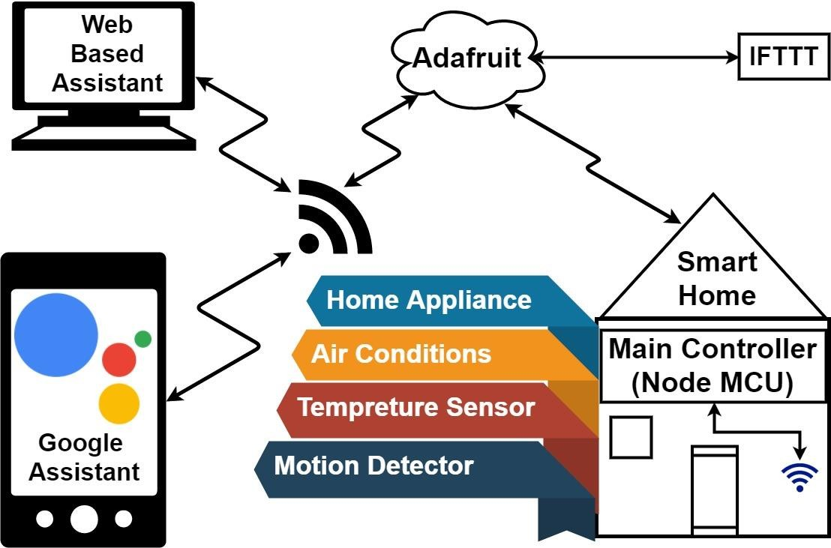

Fig.1.1. Smart home automation system architecture

SYSTEM DESIGN AND IMPLEMENTATION

Speech is one of the most important inputs used for man machine interaction. Therefore, to make smart home more user friendly, Google assistance along with web based application can be used to control the home system. The advantage of multimodal is that in the presence of the noisy background surrounding the performance of the Google assistance degrades. Hence, in such scenario web based application can be helpful in controlling the appliance of the system. Thus, the proposed model is designed to provide better flexibility and making the system more robust.

Figure shows the general architecture of the smart home automation system. As shown in the Figure the smart home can be implemented with main controller unit (Main switching of the home circuit) that is connected with the 24-hour available Wi-Fi network. To ensure, that the Wi-Fi connection do not turn off, the main controller is programmed to establish automatic connection with the available network and connected to the auto power backup.

# Chapter 2 Literature Review

In this section, discussed different Home Automation System with their technology with features, benefit and limitations they have. “The Figure” shows Basic Architecture of Remote Home Automation.

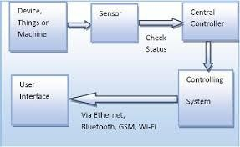

Fig 2.1: Basic Block Diagram of Home Automation

The Home automation system that uses Wi-Fi technology. System consists of three main components; web server, which presents system core that controls, and monitors users’ home and hardware interface module(Arduino PCB (ready-made), Wi-Fi shield PCB, 3 input alarms PCB, and 3 output actuators PCB.), which provides appropriate interface to sensors and actuator of home automation system. The System is better from the scalability and flexibility point of view than the commercially available home automation systems. The User may use the same technology to login to the server web based application. .If server is connected to the internet, so remote users can access server web based application through the internet using compatible web browser.

The application has been developed based on the android system. An interface card has been developed to assure communication between the remote user, server, raspberry pi card and the home Appliances. The application has been installed on an android Smartphone, a web server, and a raspberry pi card to control the shutter of windows. Android application on a smartphone issue command to raspberry pi card. An interface card has been realized to update signals between the actuator sensors and the raspberry pi card.

Cloud-based home appliance monitoring and controlling System. Design and implement a home gateway to collect metadata from home appliances and send to the cloud-based data server to store on HDFS (Hadoop Distributed File System), process them using Map Reduce and use to provide a monitoring function to Remote user. It has been implemented with Raspberry Pi

through reading the subject of E-mail and the algorithm. Raspberry Pi proves to be a powerful, economic and efficient platform for implementing the smart home automation. Raspberry pi based home automation is better than other home automation methods is several ways. For example, in home automation through DTMF (dual tone multi-frequency), the call tariff is a huge disadvantage, which is not the case in their proposed method. Also, in Web server based home automation, the design of web server and the memory space required is ejected by this method, because it simply uses the already existing web server service provided by G-mail. LEDs were used to indicate the switching action. System is interactive, efficient and flexible.

Shih-Pang Tseng et al. proposed Smart House Monitor & Manager (SHMM), based on the ZigBee, all sensors and actuators are connected by a ZigBee wireless network. They designed a simple smart socket, which can remote control via ZigBee. PC host is used as a data collector and the motion sensing, all sensing data are transferred to the VM in the cloud. The user can use the PC or Android phone to monitor or control through the Internet to power-saving of the house.

# Chapter 3

Problem statement and objective

## Problem Statement:

* + - Sub systems not integrating.
    - Too many home automation control apps.
    - Sub system suppliers lacking smart knowledge.

## Objective:

* + - To ease daily life by increasing user comfort.
    - To manage all your home devices from one place.
    - To increase energy efficiency using smart home technology.
    - To improve appliance functionality to help run your appliances better.

# Chapter 4 Methdology

The application of IoT in different sectors and industries has been widely discussed and reviewed in the literature (for example. Moreover, challenges and opportunities with respect to the deployment of one or a group of IoT technologies have received a high level of technical assessment, sensors or 5G network. With respect to the energy sector, most of survey studies have focused on one specific subsector, e.g., buildings or the technical potential of a certain IoT technology in the energy sector. reviews smart home applications of IoT and the prospect of integrating those applications into an IoT enabled environment the methods, recent advances, and implementation of 5G are studied only with focusing on the energy demand side.

The role of IoT in improving energy efficiency in buildings and public transport has been discussed in, respectively. reviews the key challenges in the suitability of IoT data transfer and communication protocols for deployment in smart grids. However, unlike the reviewed literature where the focus is commonly either on a specific subsector in the energy sector or certain IoT technologies, this paper reviews the application of IoT in the energy sector, from energy generation to transmission and distribution (T&D) and demand side. As such, the main contribution of this paper is to extend the existing body of literature by providing energy policy- makers, economists, energy experts, and managers with a general overview of the opportunities and challenges of applying IoT in different parts of the entire energy sector. In this respect, we briefly introduce the IoT framework and its enabling technologies to form a basis for discussing their role in the energy sector.

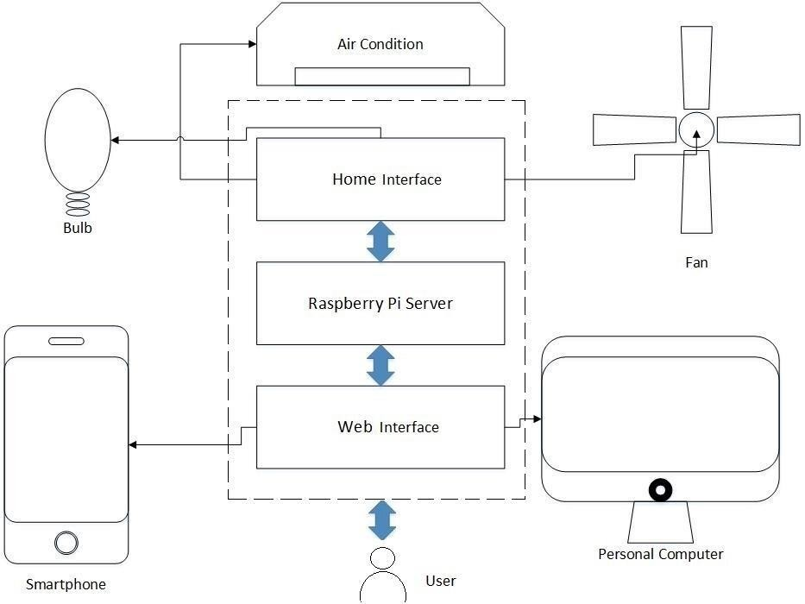

Fig 4.1 proposed system

To conduct this survey, a systematic search was carried out to collect and review the recent body of literature on the role of IoT in the energy sector. First, we searched the terms “Internet of Things” and “Energy”, case non-specific, in the title, abstract, Then, we limited the scope of search results to engineering, economics and management branches where possible. Next, papers published before 2012 and most of conference papers with no information on the peer-review process were excluded. Finally, we clustered the relevant papers in sub-categories of energy generation (including power plants, ancillary services, and centralized renewable energy), T&D systems (including electricity, gas and district heating networks, and smart grids), and the demand side (including energy use in buildings, transportation, and the industry sector). We focus on the IoT applications that can be generally applicable to most of energy systems without discussing specific cases and their boundary conditions. For example, we discuss the role of IoT in smart buildings, without falling into the details of building typology, building material, occupants’ energy consumption pattern, type and number of home appliances, etc.

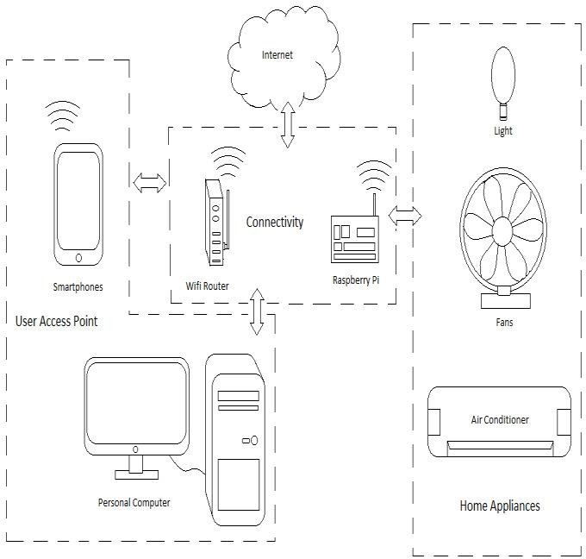

fig 4.2 connections

# Chapter 5 UML Diagrams

The Unified Modeling Language is a standard visual modeling language intended to be used for modeling business and similar processes, analysis, design, and implementation of software-based systems.

###### Goals of UML

There are a number of goals for developing UML but the most important is to de ne some general purpose modeling language which all modelers can use and also it needs to be made simple to understand and use. UML diagrams are not only made for developers but also for business users, common people and anybody interested to understand the system. The system can be a software or non software. So it must be clear that UML is not a development method rather it accompanies with processes to make a successful.

At the conclusion the goal of UML can be defined as a simple modeling mechanism to model all possible practical systems in today's complex environment. UML diagrams are the ultimate output of the entire discussion. All the elements, relationships are used to make a complete UML diagram and the diagram represents a system.

* + - Use case Diagram
    - Data flow Diagram
    - Activity Diagram
    - Sequence Diagram
  1. **Use case Diagram:**

A use case diagram at its simplest is a representation of a user's interaction with the system that shows the relationship between the user and the different use cases in which the user is involved.

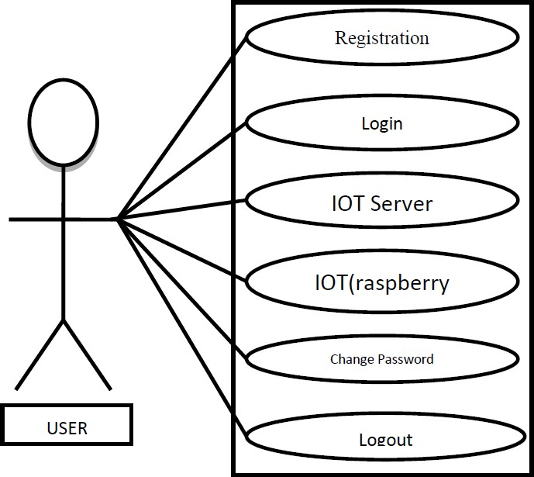

Fig 5.1 system use case diagram

In use case diagram user will perform operations on smart home application. User will able to create account itself. And he will be able to perform he all tasks of all appliances from mobile app smart home.

#### Data flow diagram:

Data flow diagrams are used to graphically represent the flow of data in a business information system. DFD describes the processes that are involved in a system to transfer data from the input to the file storage and reports generation.

###### Data flow diagram level 0:

DFD Level 0 is also called a Context Diagram. It's a basic overview of the whole system or process being analyzed or modeled. It's designed to be an at-a-glance view, showing the system as a single high-level process, with its relationship to external entities.

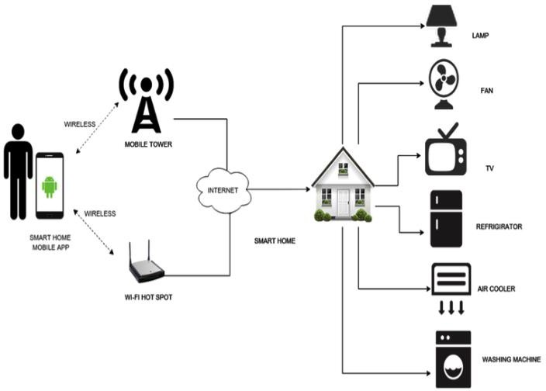

Fig 5.2 – Data Flow Diagram (level 0)

###### Data Flow Diagram level 1:

Context diagrams (level 0 DFDs) are diagrams where the whole system is represented as a single process. A level 1 DFD notates each of the main sub-processes that together form the complete system. We can think of a level 1 DFD as an “exploded view” of the context diagram.

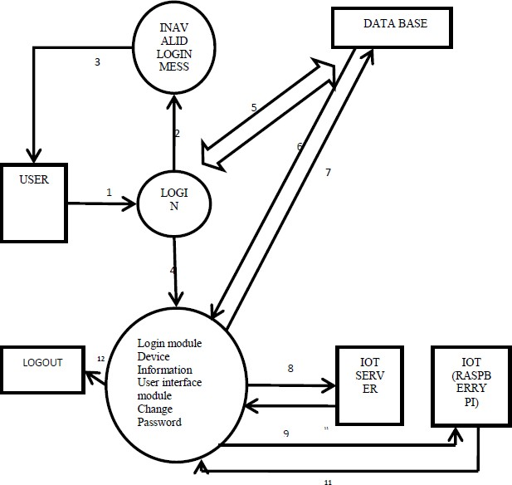

Fig 5.2.1 Data Flow Diagram.(Level 1)

#### Activity diagram:

An activity diagram illustrates one individual activity. In our context, an activity represents a business process. Fundamental elements of the activity are actions and control elements (decision, division, merge, initiation, end, etc.).

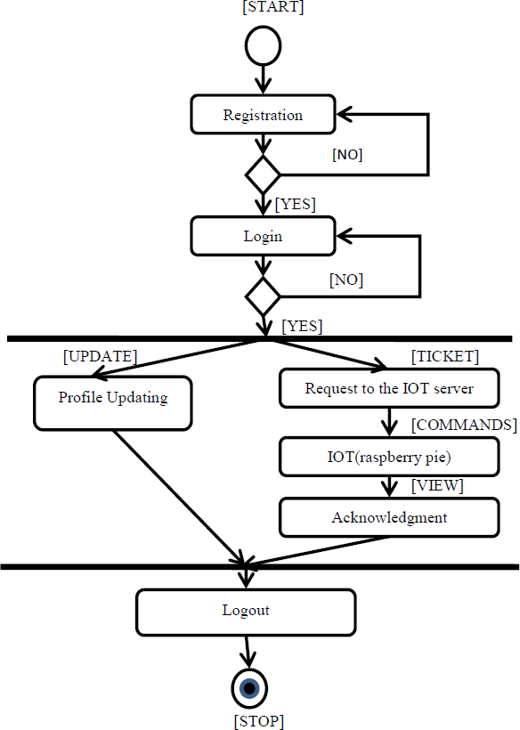

Figure 5.3 Activity Diagram of Admin

Activity diagram includes all types of rows like sequential, concurrent or branched with decisions. It is nothing but preview of system execution or how system will execute once project will complete.

#### Sequence Diagrams:

A sequence diagram is an interaction diagram. From the name it is clear that the diagram deals with some sequences, which are the sequence of messages owing from one object to another.

Interaction among the components of a system is very important from implementation and execution perspective. So Sequence diagram is used to visualize the sequence of calls in a system to perform a specific functionality.

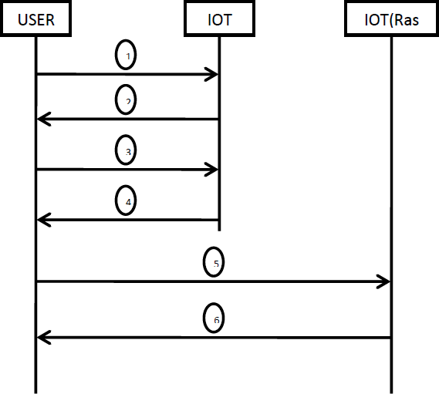

Figure 5.4 sequence Diagram

1. User logins and request for the ticket to IOT server to establish communication between user and IOT(raspberry pie)
2. IOT server creates a ticket which is encrypted by user public key and sent to user
3. User decrypts it using is private key and hash it using hashing function and sends to IOT server
4. IOT server sends and acknowledgment back to server
5. Now a secure connection is established between user and IOT (raspberry pie). User send the ticket and a command to be operated.
6. In-return the IOT( Raspberry pie) sends an acknowledgement back to user*.*

# Chapter 6 System Requirements

### Hardware Requirement:

* + Raspberry Pi 3, Model B, v 1.2, which is the IoT computer that will control the devices that comprise the home automation system
  + 433-MHz receiver and transmitter modules, which receive signals from, and transmit signals to, the system
  + Wireless electrical outlets that listen for on/off signals in the 433 MHz band and respond accordingly
  + Wireless home alarm system with window and door sensors that are controlled by and report status by using signals in the 433 MHz frequency band

### Software Requirement:

* + IoT device (sensor or actuator) software
  + Gateway software
  + Smartphone app
  + Cloud software

# Chapter 7 Conclusion

It is very important to develop a smart home system which is affordable to everyone and which can accomplish the user's daily needs. More than that the people should know the usability of the current technology how it can be a part of their life and make them more productive.

Currently the people are with the conventional methods. They are bullied by them and not ready to go with a smart home having a mind-set that its installation and maintenance are very expensive. The awareness on the technologies and making it more affordable can make the difference.

Mr. Nagane Abhijit Shantaram Mr. Mutkule Abhijeet Kashinath

Mr. Kolhe Pranjal Milind Mr. Pathak Vinayak Vijay

Prof. V. A. Dhotre

(Students) (Project Guide)

Prof. N. M. Sawant (Head of Dept.)

Computer Science & Engg., SKN Sinhgad College of Engg., Korti.

# Chapter 8 References

1. Stergioua C, Psannis KE, Kimb B-G, Gupta B. Secure Integration of IoT and Cloud Computing. Elsevier, Future Generation Computer Systems, Vol. 78. Part 3. January 2018.
2. Al-Kuwari M, Ramadan A, Ismael Y, Al-Sughair L, Gastli A, Benammar M.Smart-Home Automation Using IoT-Based Sensing and Monitoring Platform, IEEE. 2018. Available from: ieeexplore.ieee.org
3. Datta T, Apthorpe N, Feamster N. Developer-friendly library for smart home IoT privacy- preserving traffic obfuscation, IoT S&P 18. In: Proceedings of the 2018 Workshop on IoT Security and Privacy.
4. Learning Algorithms in Smart Home IoT System Security. American Institute of Mathematical Sciences; 2018. DOI: 10.3934/mfc.2018004

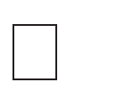-based intelligent modeling of smart home environment for fire prevention and safety. Journal of Sensor and Actuator Networks. 2018; (1):11. DOI: 10.3390/jsan7010011

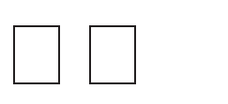

of things: A survey. Future Generation Computer Systems. 2016; :684-700

1. Soliman M, Abiodun T, Hamouda T, Zhou J, Lung C- of things with web services and cloud computing. In: International Conference on Cloud Computing Technology and Science; IEEE. 2013
2. -Based Event Processing and Reaction Rules. London: Betfair Ltd; 2009.
3. 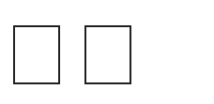-time analysis of a sensor’s data for automated decision making in an IoT-based smart home. Sensors. 2018; :1711. DOI: 10.3390/s18061711
4. 

Proceedings of the 25th International Florida Artificial Intelligence Research Society Conference. Association for the Advancement of Artificial Intelligence; 2012

1. Rintala, Mikko, Jussi Sormunen, Petri Kuisma, and Matti Rahkala. & quot; Automation System Products and Research.&quot;(2014).
2. Sandeep Patel, Punit Gupta, Mayank Kumar Goyal, &quot; Low Cost Hardware Design of a Web Server for Home Automation Systems&quot;, Conference on Advances in Communication and Control Systems(CAC2S), 2013.
3. Golzar, M.G. ; AsanPardazan Co. ; Tajozzakerin, H.R., &quot;A New Intelligent Remote Control System for Home Automation and Reduce Energy Consumption&quot;, Mathematical/Analytical Modelling and Computer Simulation (AMS), 2010, IEEE.
4. Vishwajeet H.Bhide “A Survey on the Smart Homes using Internet of Things (IoT)”
5. Rahul Godha, Sneh Prateek, Nikhita Kataria “ Home Automation: Access Control for IoT Devices” International Journal of Scientific and Research Publications, Volume 4, Issue 10,

October 2014 1 ISSN 2250-3153

1. Al-Ali, Member, IEEE & M. AL-Rousan,“Java-Based Home Automation System R.” IEEE Transactions on Consumer Electronics, Vol. 50, No. 2, MAY 2004
2. Alkar, A.Z., Hacettepe Univ; Roach, J. ; Baysal, D., &quot;IP based home automation system&quot;, Consumer Electronics, IEEE Transactions on (Volume:56 ,Issue: 4), November 2010,IEEE.